Class XI
FINAL TERM EXAMINATION
SESSION 2024-25
SUBJECT- ECONOMICS
M.M. 80 TIME 3HRS
‐—-----------------------------------------------------------------------------------------------------------------
GENERAL INSTRUCTIONS -
1. All Questions are compulsory to be attempted.
2. This question paper contains two sections :
Section A – Statistics ( 40 marks)
Section B – Micro Economics (40 marks)
3. Marks for questions are indicated against each question.
4. Q.No. 1 to 10 and 18 to 27 are Objective Type Questions carrying 1 mark each.
5. Q.No. 11 to 12 and 28 to 29 are Short Answer Type Questions carrying 3 marks each.
6. Q.No. 13 to 15 and 30 to 32 are also Short Answer Type Questions carrying 4 marks each.
7. Q.No. 16 to 17 and 33 to 34 are Long Answer Type Questions carrying 6 marks each.
--------------------------------------------------------------------------------------------------------------------------
SECTION A
( STATISTICS )
- Arithmetic mean of a series is 15 and if 5 is added in all the items of this series, the new arithmetic mean will be ______.
- 5 b) 20
c)18 d) 10

In the following questions (2 - 3), a statement of Assertion (A) is followed by a statement of Reason (R). Choose the correct alternative among those given below:
Alternatives:
(a) Both Assertion (A) and Reason (R) are true and Reason (R) is the correct explanation of Assertion (A)
(b) Both Assertion (A) and Reason (R) are true and Reason (R) is not the correct explanation of Assertion (A)
(c) Assertion (A) is true but Reason (R) is false
(d) Assertion (A) is false but Reason (R) is true

- Assertion (A): Primary data are original.
Reason (R) Primary are the data collected from the source of origin.
OR
Assertion (A): Enumerator is a person who helps the investigator in collecting the data.
Reason (R): Investigator is a person who answers to the set of questions included in the questionnaire.
- Assertion (A): Mid-value is the difference between the upper limit and the lower limit of a class.
Reason (R) : Frequency is the number of times an item repeats itself in the series.
- Consumer Price Index is also known as ________.
(a) Industrial Production Index (b) Wholesale Price Index
(c) Cost of Living (d) none of these
- When two variables change in the same direction, then such a correlation is called _____.
(a) negative (b) positive
(c) no correlation (d) all of these
- Median of these numbers: 3, 5, 7, 9, 12 is:
(a) 3 (b) 6
(c) 7 (d) 12

In the following questions (7-8), two statements are given. Read the statements carefully and choose the correct alternative among those given below:
Alternatives:
(a) Both the statements are true
(b) Both the statements are false
(c) Statement 1 is true and Statement 2 is false
(d) Statement 2 is true and Statement 1 is false

- Statement 1: Deviation bar diagrams represent positive and negative deviations as above and below the base line.
Statement 2: Component bar diagrams simultaneously present total values as well as part values of a set of data.
Statement 1: The breadth of the bar changes in case of bar diagrams.
Statement 2: Bars are also called rows.
OR
- Statement 1: Title of the table must be compatible with the objective of the study.
Statement 2: Caption is the title given to the rows of a table.

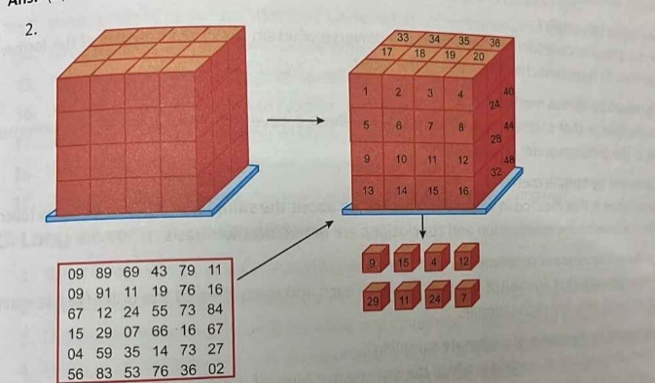
The diagram above highlights ___ sampling.
(a) random (b) Non-random
(c) dice (d) Tippet's table
- From the set of statements given in Column I and Column II, choose the correct pair of statements:
Column I Column II
A. Primary source of data (i) Collection of data from some agency or institution
B. Secondary data (ii) First-hand data
C. Direct Personal Investigation method (iii) Collected data have a less degree of originality
D. Enumerator's method (iv) A questionnaire is prepared according to the purpose of enquiry
Alternatives:
(a) A-(i) (b) B-(ii)
(c) C-(iii) (d) D-(iv)
11. Highlight the importance of Statistics in economics?
OR
Distinguish between Microeconomics and Macroeconomics? [3]
12. Discuss the ‘weighted’ and ‘unweighted’ index of price? [3]
13. Marks secured by 42 students in economics are [4]
Marks | 15 | 20 | 22 | 23 | 27 | 35 | 18
No. of students | 8 | 4 | 7 | 3 | 8 | 7 | 5
Find Average marks.
14. Given the following data, find out Median.
Age | 20-25 | 25-30 | 30-35 | 35-40 | 40-45 | 45-50 | 50-55 | 55-60
No. of students | 50 | 70 | 100 | 180 | 150 | 120 | 70 | 60
OR

Calculate the Mode from the following data. [4]
Wages | 0-10 | 10-20 | 20-30 | 30-40 | 40-50
No.of students | 28 | 46 | 54 | 42 | 30

15. Find the consumer price Index for the current year from the following data by:
a) Aggregate Expenditure Method b) Family Budget Method [4]

Articles | Rice | Wheat | Pulses | Ghee | Oil | Clothing | Firewood | House Rent
Quantity consumed in Base Year | 5 qt | 1qt | 2qt | 4qt | 5 l | 40 metres | 10 qt | 1 house
Price in Base Year | 24 per qt | 16 per qt | 12 per qt | 5 per kg | 4 per l | 1 per metre | 2 per qt | 20 per house
Price in current Year | 30 per qt | 20 per qt | 18 per qt | 6.25 per kg | 5 per l | 1.50 per metre | 2.50 per qt | 25 per house

OR

Study the following data carefully and answer the questions 1 – 4 on the basis of the same:
∑$P_{1}Q_{0}$ | ∑$P_{0}Q_{0}$ | ∑$P_{1}Q_{1}$ | ∑$P_{0}Q_{1}$
235 | 187 | 250 | 233
- The value of index number for the above data using Laspeyre’s method _________.
- 125.67
- 107.29
- 116.12
- 135.8
- Index number for the base year is always considered as _______.
- 100
- 1000
- 1
- 0
- Price relatives are a percentage ratio of current year price and base year quantity.
( True or False )
- Read the following statements carefully and choose alternative among those given below:
Statement I : While constructing index number, weights are accorded to different commodities according to their relative significance.
Statement II : Index numbers help to ascertain the living standards of the people.

Alternatives :
- Both the statements are True.
- Both the statements are False.
- Statement I is True and Statement II is False.
- Statement I is False and Statement II is True .
16. Describe the main stages of Statistics and the related tools? [6]
OR
Define Statistics ? Discuss its importance and limitations?
17. Calculate the coefficient of correlation for the following data by Actual Mean method. [6]
X | 2 | 4 | 6 | 8 | 10 | 12
Y | 6 | 12 | 18 | 24 | 30 | 36

OR
Calculate coefficient of rank correlation between the marks in Economics and Statistics , as indicated by 8 answer books of each of the two examiners.

Marks in Statistics | 15 | 10 | 20 | 28 | 12 | 10 | 16 | 18
Marks in Economics | 16 | 14 | 10 | 12 | 11 | 15 | 18 | 12

--------------------------------------------------------------------------------------------------------------------------
SECTION B
( MICRO ECONOMICS )
In the following questions ( 18 - 20 ), a statement of Assertion (A) is followed by a statement of Reason (R). Choose the correct alternative among those given below:
Alternatives:
(a) Both Assertion (A) and Reason (R) are true and Reason (R) is the correct explanation of Assertion (A)
(b) Both Assertion (A) and Reason (R) are true and Reason (R) is not the correct explanation of Assertion (A)
(c) Assertion (A) is true but Reason (R) is false
(d) Assertion (A) is false but Reason (R) is true
18. Assertion (A): When price of a good increases, demand for its substitute good rises and vice versa.
Reason (R): Substitute goods are those goods which can be interchanged for use.
OR
Assertion (A): With fall in price of a commodity, real income of the consumer increases.
Reason (R): Less of the good can be brought at the same absolute income.

19. Assertion (A): At producer's equilibrium, MR = MC and MC must be rising at the equilibrium level of output.
Reason (R): At producer's equilibrium, AR should at least be equal to AVC.

20. Assertion (A): When there is excess demand in the market, price will tend to rise.
Reason (R): The government fixes ceiling price to regulate income of the farmers.
21. Ordinal concept of utility expresses utility in terms of:
(a) level of satisfaction (b) diminishes
(c) units (d) none of these
22. A shift in the budget line, when prices are constant, is due to:
(a) change in demand (b) change in income
(c) change in preferences (d) change in utility
23. When there is no change in quantity demanded in response to any change in price, it is a
situation of:
(a) zero price elasticity (b) unitary price elasticity
(c) infinite price elasticity (d) none of these
24. From the set of statements given in Column I and Column II, choose the correct pair of statements:
Column I Column II
A. Utility (i) Profit derived from the consumption of a commodity
B. Marginal utility (ii) Sum total of utility derived from the consumption of all the units of a commodity
C. Maximum TU (iii) When MU is positive
D. Decreasing MU (iv) Implies that TU is increasing at a decreasing rate
Alternatives:
(a) A-(i) (b) B-(ii)
(c) C-(iii) (d) D-(iv)
In the following questions (25 – 26 ), two statements are given. Read the statements carefully and choose the correct alternative among those given below:
Alternatives:
(a) Both the statements are true
(b) Both the statements are false
(c) Statement 1 is true and Statement 2 is false
(d) Statement 2 is true and Statement 1 is false

25. Statement 1: When average revenue is diminishing, it is greater than marginal revenue.
Statement 2: MR can be negative but not AR.
OR
Statement 1: MR can never be equal to price of the commodity.
Statement 2: When MR is constant, TR should be increasing at a constant rate.
26. Statement 1: Supply and quantity supplied are identical terms.
Statement 2: Market supply schedule refers to supply schedule of the industry as a whole.

27.
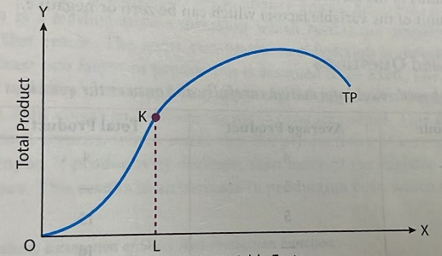

On the basis of the above diagram, what does point K indicate?
(a) Point of saturation (b) Point of inflexion
(c) Point of satiety (d) Point of inflation

28. When Price of rice is Rs. 10 per kg, its demand is 100 kg. When price rises by Rs. 10 per kg, its demand falls by 20 kg. Calculate the elasticity of demand. (3M)
OR
What is meant by Price elasticity of demand? How is it measured ?
29. Explain relationship between Marginal cost and Average Cost with the help of schedule and Graph ?

OR

Find implicit and explicit cost from the following data : (3M)

ITEMS | ( Rs. In ‘000 )
- Investment in machinery and fixed assets | 3000
- Borrowing at 15 % interest per year | 2000
- Wages and salaries paid during an year | 150
- Estimated yearly rental value of owners own factory building | 120
- Depreciation per year | 120
- Expected value of managerial services rendered by the owner | 300

30. What is Production Possibility Curve ( PPC) with assumption with the help of schedule and diagram ? (4M)
OR
Explain in detail the concept of Opportunity Cost with the help of schedule and diagram ?
31. What is perfect competition ? Explain the following features of perfect competition:
i. Large number of buyers and sellers
ii. Homogeneous products (4M)
32. Read the following hypothetical information carefully and answer the questions I – IV on the basis of the same :

PRICE ( RS. ) | SUPPLY ( UNITS )
1 | 5
5 | 10
10 | 15

- On the basis of the data given above when price changes from Rs. 1 to Rs.5, that situation will be called _______.
- Extension of supply
- contraction of supply
- increase in supply
- decrease in supply
- On the basis of the data given above when price changes from Rs. 10 to Rs. 1, that situation will be called _______.
- Extension of supply
- contraction of supply
- increase in supply
- decrease in supply
- If the producer expects price of the commodity to rise in the near future, current supply of the commodity will reduce. ( True / False )
- Read the following statements carefully and choose the correct alternative among those given below :
STATEMENT I : Increase in supply occurs when more is supplied at the existing price.
STATEMENT II : Decrease in supply leads to a backward shift in supply curve.

Alternatives :
- Both the statements are True.
- Both the statements are False.
- Statement I is True and Statement II is False.
- Statement I is False and Statement II is True .
33. Explain the conditions of producer’s equilibrium with the help of a schedule
diagram ? (6m)
OR
What is meant by producer’s equilibrium? When will a producer be in equilibrium in case of losses?
34. What is Market equilibrium? Explain its shift (change) in demand and Market
Equilibrium and shift (change) in supply and Market Equilibrium ? (6m)
OR
- Explain the following terms : i. Price ceiling ii. Price floor ( 3 m)
- Discuss determination of Market Equilibrium under perfect competition? ( 3 m)

